National University of Computer and Emerging Sciences Islamabad Programming Fundamentals Lab FALL 2022

**Lab Manual 05**

**Operators, Expressions and Precedence**

1. **Variables: Data Types, sizeof and Polarity:**

**Example 1.1:**

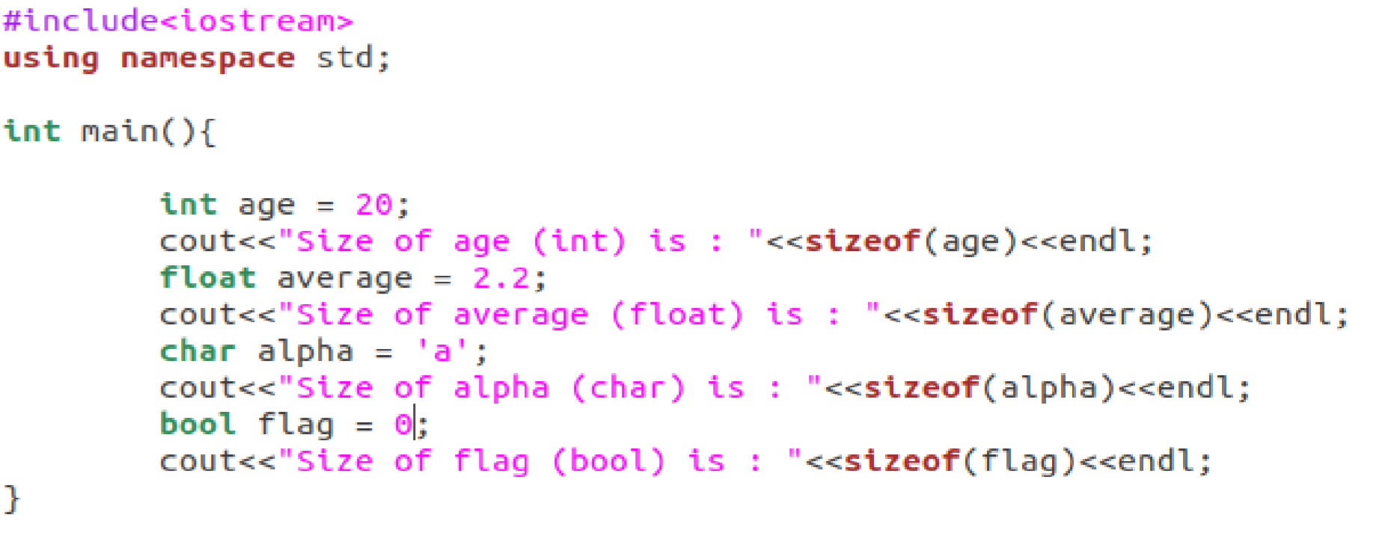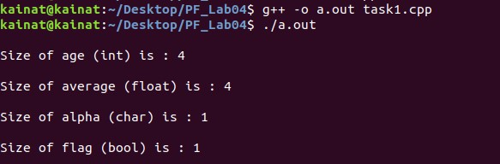

**Example 1.2:**

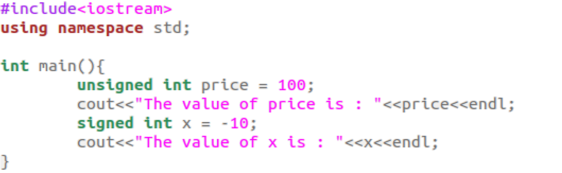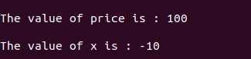

1. **Operators:**

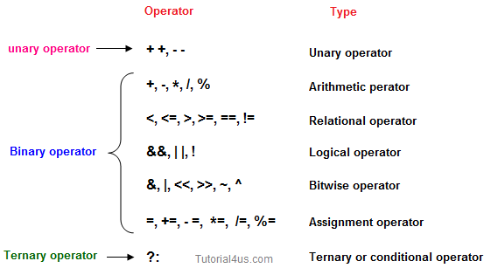

**Arithmetic Operator**

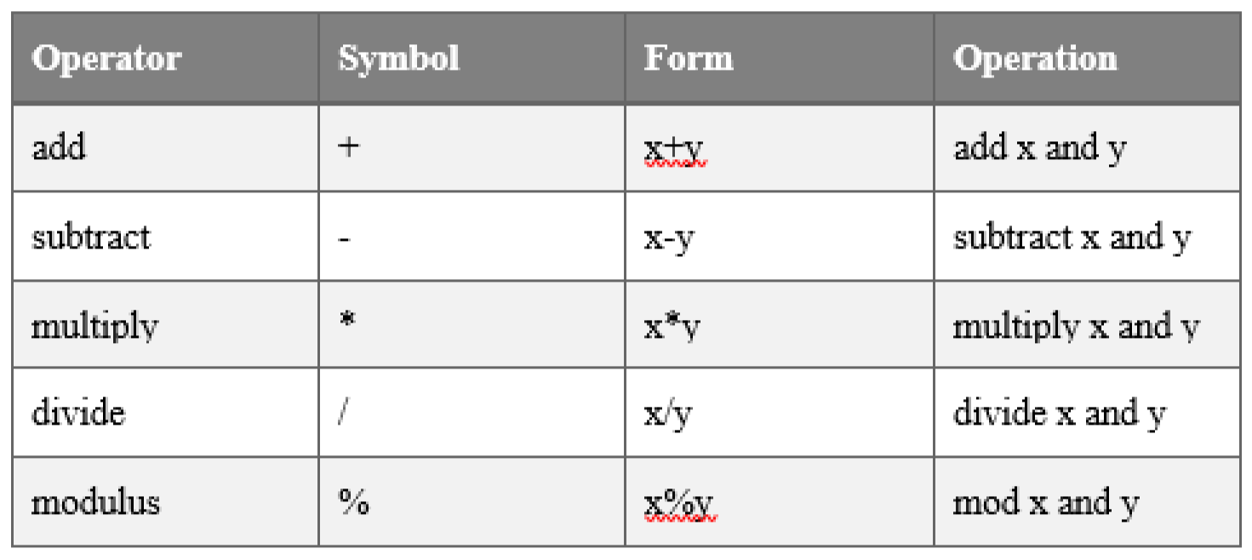

**Lab Tasks**

**Problem 01**

**Example 2.1:**

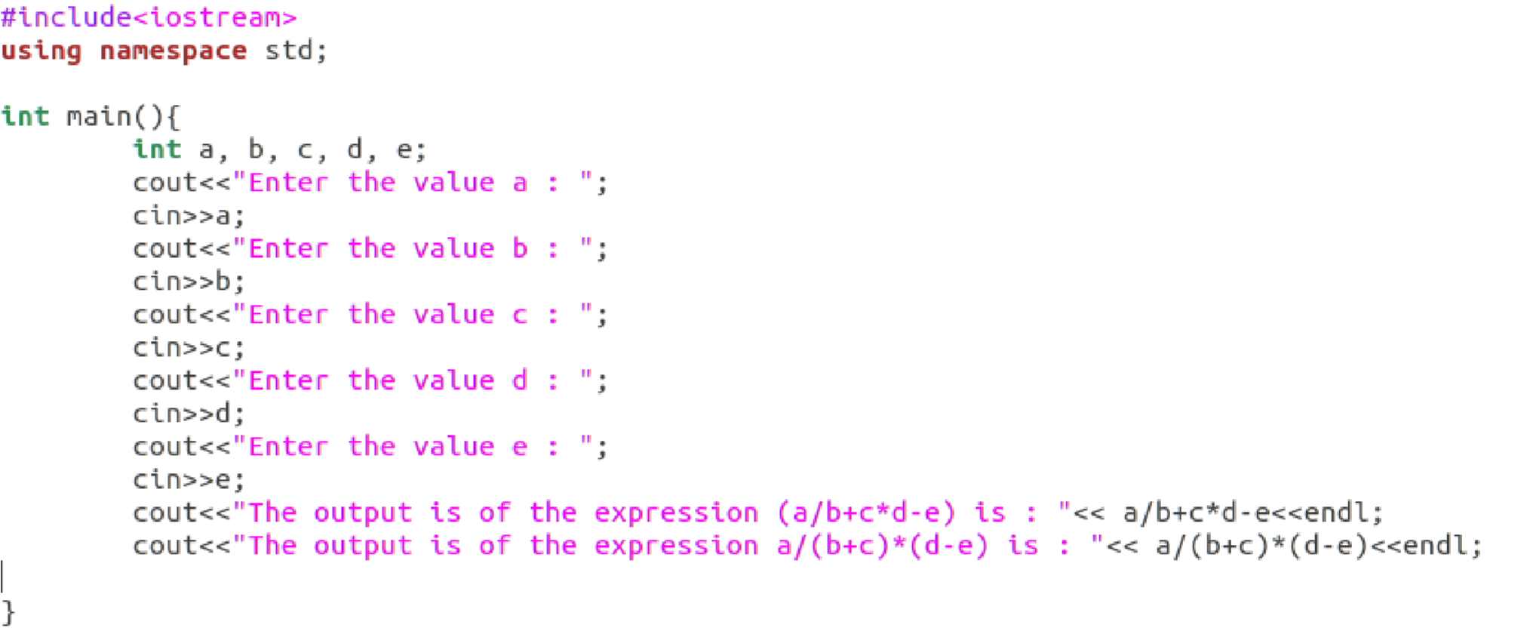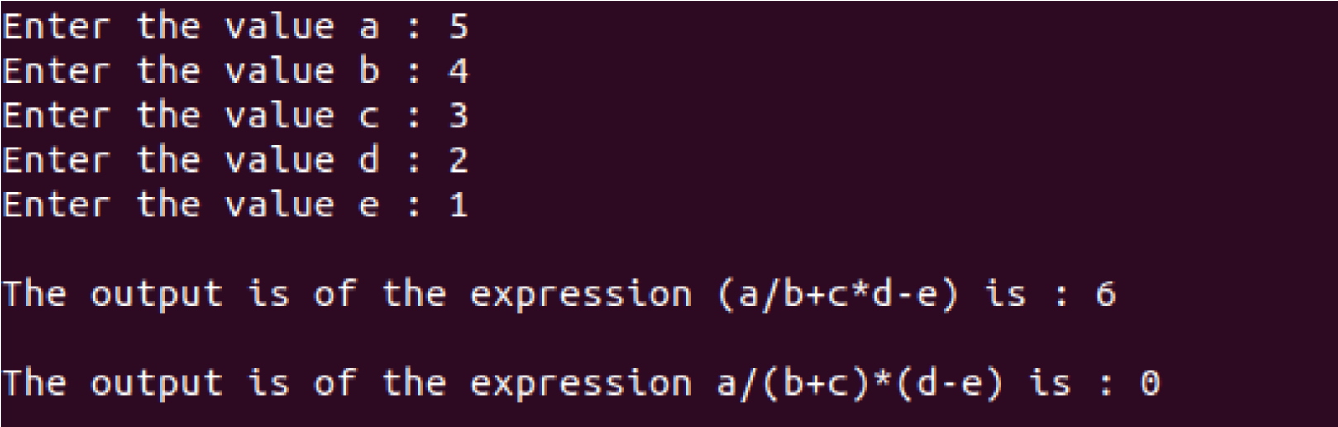

Write a program to find circumference of a circle. The program should take radius input from user and display the circumference.

𝑐𝑖𝑟𝑐𝑢𝑚𝑓𝑒𝑟𝑒𝑛𝑐𝑒 = 2𝜋𝑟 (𝑤ℎ𝑒𝑟𝑒 𝑃𝐼 𝑖𝑠 𝑎 𝑐𝑜𝑛𝑠𝑡𝑎𝑛𝑡 𝑣𝑎𝑙𝑢𝑒 𝑜𝑓 3.1415 𝑎𝑛𝑑 𝑟 𝑖𝑠 𝑟𝑎𝑑𝑖𝑢𝑠)

***Note: Declare PI as constant***

**Problem 02**

There are three seating categories at a stadium. For a football game, Class A seats cost 150, Class B seats cost 140, and Class C seats cost 190. Write a program that asks how many tickets for each class of seats were sold, then displays the amount of income generated from ticket sales. Format your dollar amount in fixed-point notation, with three decimal places of precision, and be sure the decimal point is always displayed.

**Problem 03**

Write a program that asks a shopkeeper to input unit price of chocolate mini bar and stores in a variable. It then asks to input the quantity of chocolates sold in a particular day and store in another variable. Now it calculates and displays the total sales amount of chocolates earned by the shopkeeper. Now calculate 15% tax on total sales amount and store in another variable. Display the total sales amount of chocolates after tax deduction.

**Problem 04**

Write a program to find and display result for cube of two numbers using following formula in a single expression:

**a3 + 3a2b + 3ab2 + b3**

# Note: Get the values of a, b from user. Perform the above task with only one mathematical equation. Keep the concept of operator precedence in mind.

|  |
| --- |
| **Submission Instructions:**  1.Save all **.cpp** files with your roll no and task number  **e.g. i22XXXX_Section_Task05.cpp**   1. Now create a new folder/directory with name *ROLLNO_SECTION_LAB05*   **e.g. i22XXXX_ Section_LAB05**   1. Move all of your .cpp files to this newly created directory and compress it into **.zip file**. 2. Now you have to submit this zipped file on Google Classroom. |

**THE END**